38th Year - UK INTERNATIONAL Open
Karate Championships
Saturday 16th SEPTEMBER 2023
University of Warwick Sports Centre
CV4 7EU
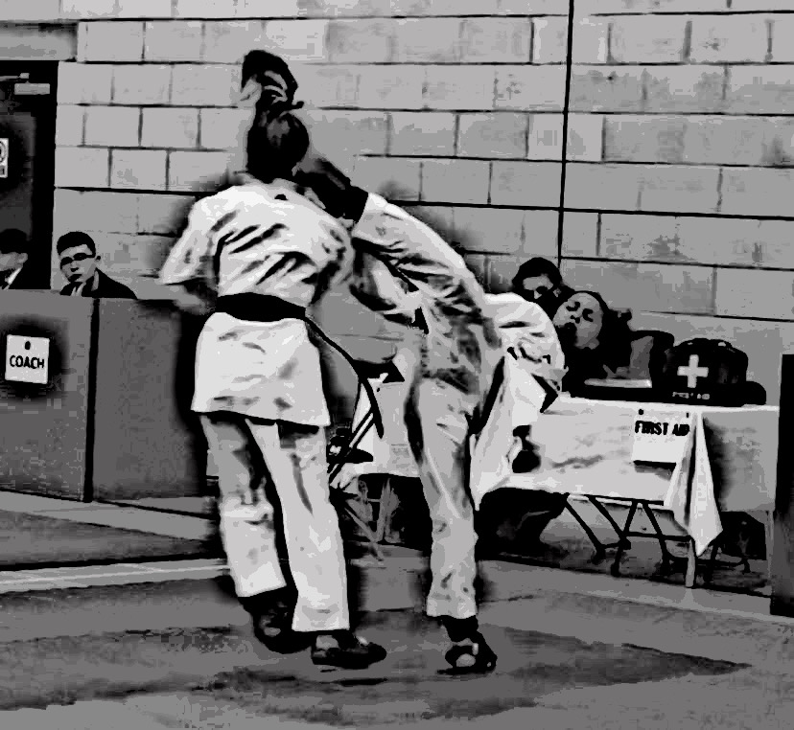
Cryfield Village, Warwick
Enter via: SPORTS DATA
(Registration Open :10th May 2023)

Individual events – Kata & Kumite £22.00 per event
Team events - £40.00
Spectators : £15.00 ( Under 5s Free) Pre booked these will be on reception on the day.

Doors Open : 7.30am Competition Starts 9am Prompt

World (WKF), European (EKF), British (BKF) & English (EKF) Qualified Referee

Please contact me direct to officiate, Judge or Referee at this championship.
Email: Paulcampbell12@hotmail.com.
Expenses/Payments and Refreshments :
Association officials £75
National Judges £85
Qualified Referees £105
International Officials £135
Information

Please register all your Coaches via sports data, coaching badges will only be given to those who have registered.
5 Competitors – 1 – Coach
6 – 10 Competitors – 2 Coaches
11 – 20 Competitors – 3 Coaches
21+ 4/5 Coaches
Refreshments, including Lunch will be available to registered Coaches.

All entries for the UK International Karate Championships will be held on a waiting list until the payment has been received via Bank Transfer

Payments : Bank: Monzo. Sort Code: 04-00-04. Account: No: 74520574.
Please Reference under your Name/Club/Association.

Registration closing 3rd September 2023
NO CHANGES AFTER THIS DATE

PARKING YOUR CAR
Please park at Cryfield Village where the cost is £1 for the day.
Register and pay via the App on the Car Park.

CV4 7EU, This is a blanket Postcode so we recommend using ‘Leighfield Road’ for any Sat Navs.

Officials and Coaches
There will be a Referee and Table Officials and Coaches briefing at 8.30am in the Main Arena.

Warm Up Area
Adjacent to Sport Hall there is a large separate matted ‘Warm up/holding area.
Competitors will be called for their bouts from here.

Refreshments
Are available close to the Entrance Reception Area, where Tea, Coffee and snacks can be purchased throughout the day.

COMPETITION RULES

All competitors are expected to be on their best behaviour at all times, no Abusive language will be tolerated the penalty may mean disqualification for the entire group.

DOCTOR /FIRST AID
Will be on hand throughout the day as medical backup, the Medical Team’s decision is final regarding the capability of a competitor to continue.

All competitors to wear a clean white traditional Karate Gi, Red or Blue Mitts allowed but matching with the belts, as per WKF Rules;
Competitors age as on day of competition;
Red and blue flags will be used;
Red and blue belts are compulsory for all events;

Protective equipment is compulsory:

1. Red & Blue Mitts
2. GumShield
3. Groin Guards
4. Female Chest Protector for 13 years+
5. Shin & Foot Pads, Red & Blue for 10 years old and over
6. Body Armour Everyone 14 Years & Above.

Junior Competitors (under 16yrs) are advised to bring with them a valid Licence or their Birth Certificate *

Weigh In will be completed on the day of competition

Any person in the wrong category either through Age or Weight will be disqualified with no refund.

BOUT DURATION

The competition is touch contact based on W.K.F Rules with slight modifications for -14s.
All eliminations are by straight K.O.

Under 14s : 1.30 minutes
Cadets/Junior : 2 minutes
Senior 18+ : 3 minutes

Team Kumite - may be composed from 2 or 3 competitors;

No repechage.

Each event will be fought to the finish, no waiting for the finals at the end of the night. Dependant on the amount of competitors on the day timings may be Increased/Decreased.

REGISTRATION WILL CLOSE 3rd SEPTEMBER 2023 AND NO CHANGES WILL BE MADE AFTER THIS DATE.

(NO ENTRIES AFTER THIS DATE)
MAXIMUM : 700 COMPETITORS

PARA CATEGORY NUMBER | GENDER M/F | DISCIPLINE | GRADE/ WEIGHT | AGE | COMMENTS
PK 1 | Visually  Impaired | PARA KATA |  |  | Athletes who have limited vision in both eyes and who have no vision in both eyes
PK 2 | Intellectually impaired | PARA KATA |  |  | Impaired Athletes with a standard IQ 75 or lower
PK 3 | Intellectually Impaired | PARA KATA |  |  | Athletes with an intellectual impairment and Down Syndrome
PK4 | Intellectually Impaired | PARA KATA |  |  | Athletes who have Autism, Autism Spectrum Disorder (ASD) or Asperger's syndrome
PK5 | Standing Class | PARA KATA |  |  | Athletes with restricted joints, muscle weakness or loss of limbs, co-ordination impairments hypertonia, ataxia,
CATEGORY IND KATA NUMBER | GENDER M/F | DISCIPLINE | GRADE/ WEIGHT | AGE | COMMENTS  Kata Competitors are only able to compete within their own Age Groups
KA 00 | MALE/FEMALE | KATA | OPEN | 4 – 5 yrs  Old | HEIAN/PINAN OR EQUIVALENT KATA ONLY  KATA CAN BE REPEATED
KA 01 | MALE/FEMALE | KATA | OPEN | 6 - 7 yrs Old | HEIAN/PINAN OR EQUIVALENT KATAS  ONLY.  KATA CAN BE REPEATED
KA 02 | MALE/FEMALE | KATA | 6th KYU & BELOW | 8 – 9 YRS | HEIAN/PINAN OR EQUIVALENT KATAS  ONLY.  KATA CAN BE REPEATED
KA 03 | MALE/FEMALE | KATA | 5th KYU & ABOVE | 8 – 9 YRS | HEIAN/PINAN OR EQUIVALENT KATAS  ONLY.  KATA CAN BE REPEATED
KA 04 | FEMALE | KATA | 6th KYU & BELOW | 10 – 11 YRS | KATAS - CAN BE REPEATED  Your 1st Round  1st – 6th KATA of Your Style then Free from WKF LIST BELOW
KA 05 | FEMALE | KATA | 5th KYU & ABOVE | 10 – 11 YRS | KATAS A + B + C,  CAN BE REPEATED  SEE KATA LIST BELOW
KA 06 | MALE | KATA | 6th KYU & BELOW | 10 – 11 YRS | KATAS - CAN BE REPEATED  Your 1st Round  1st – 6th KATA of Your Style then Free from WKF LIST BELOW
KA 07 | MALE | KATA | 5th KYU & ABOVE | 10 – 11 YRS | KATAS A + B + C,  CAN BE REPEATED  SEE KATA LIST BELOW
KA 08 | FEMALE | KATA | 5th KYU & BELOW | 12 – 13 YRS | KATAS - CAN BE REPEATED  Your 1st Round  1st – 6th KATA of Your Style then Free from WKF LIST BELOW
KA 09 | FEMALE | KATA | 4th KYU & ABOVE | 12 – 13 YRS | KATAS A + B + C,  CAN BE REPEATED  SEE KATA LIST BELOW
KA 10 | MALE | KATA | 5th KYU & BELOW | 12 – 13 YRS | KATAS A + B, CAN BE REPEATED  SEE KATA LIST BELOW
KA 11 | MALE | KATA | 4th KYU & ABOVE | 12 – 13 YRS | KATAS A + B + C,  CAN BE REPEATED  SEE KATA LIST BELOW
KA 12 | CADET FEMALE | KATA | OPEN | 14 – 15 YRS | DIFFERENT KATA EACH ROUND
KA 13 | CADET MALE | KATA | OPEN | 14 – 15 YRS | DIFFERENT KATA EACH ROUND
KA 14 | JUNIOR FEMALE | KATA | OPEN | 16 – 17 YRS | DIFFERENT KATA EACH ROUND
KA 15 | JUNIOR MALE | KATA | OPEN | 16 – 17 YRS | DIFFERENT KATA EACH ROUND
KA 16 | SENIOR FEMALE | KATA | OPEN | 18 YRS + | DIFFERENT KATA EACH ROUND
KA 17 | SENIOR MALE | KATA | OPEN | 18 YRS + | DIFFERENT KATA EACH ROUND
CATEGORY KATA TEAM NUMBER | GENDER M/F | DISCIPLINE | GRADE/ WEIGHT | AGE | COMMENTS
KAT 30 | MIXED | TEAM KATA | OPEN | 9 YRS & UNDER | 3 PEEWEES TEAM  1 KATA REQUIRED
KAT 31 | GIRLS | TEAM KATA | OPEN | 10 – 13 YRS | 3 GIRLS TEAM. 1 KATA REQUIRED
KAT 32 | BOYS | TEAM KATA | OPEN | 10 – 13 YRS | 3 BOYS TEAM  1 KATA REQUIRED
KAT 33 | CADET/JUNIOR MIXED | TEAM KATA | OPEN | 14 – 17 YRS | 3 CADET/JUNIOR TEAM  1 KATA REQUIRE
KAT 34 | WOMEN | TEAM KATA | OPEN | 18 + | SENIORS  1 KATA REQUIRED
KAT 35 | MEN | TEAM KATA | OPEN | 18 + | SENIORS  1 KATA REQUIRED
CATEGORY IND KUMITE NUMBER | GENDER M/F | DISCIPLINE | GRADE/ WEIGHT | AGE | COMMENTS
KU 39 | BOYS/GIRLS | KUMITE | OPEN | 4 - 5 yrs Old | Red or Blue Belts, Mitts  Gum Shield
KU 40 | BOYS | KUMITE | 6th KYU & BELOW | 6 - 7 yrs Old | Red or Blue Belts, Mitts  Gum Shield
KU 41 | BOYS | KUMITE | 5th KYU & ABOVE | 6 - 7 yrs Old | Red or Blue Belts, Mitts  Gum Shield
KU 44 | BOYS | KUMITE | 6th KYU & BELOW | 8 – 9 YRS | Red or Blue Belts, Mitts  Gum Shield
KU 45 | BOYS | KUMITE | 5th KYU & ABOVE | 8 – 9 YRS | Red or Blue Belts, Mitts  Gum Shield
KU 46 | GIRLS | KUMITE | 6th KYU & BELOW | 8 – 9 YRS | Red or Blue Belts, Mitts  Gum Shield
KU 47 | GIRLS | KUMITE | 5th KYU & ABOVE | 8 – 9 YRS | Red or Blue Belts, Mitts  Gum Shield
KU 48 | BOYS | KUMITE | 6th KYU & BELOW | 10 – 11 YRS | Red or Blue Belts, Red or Blue Mitts,  Red & Blue Shin & Insteps &  Gum Shield
KU 49 | BOYS | KUMITE | 5th KYU & ABOVE | 10 – 11 YRS | Red or Blue Belts, Red or Blue Mitts,  Red & Blue Shin & Insteps &  Gum Shield
KU 50 | GIRLS | KUMITE | 6th KYU & BELOW | 10 – 11 YRS | Red or Blue Belts, Red or Blue Mitts,  Red & Blue Shin & Insteps &  Gum Shield
KU 51 | GIRLS | KUMITE | 5th KYU & ABOVE | 10 – 11 YRS | Red or Blue Belts, Red or Blue Mitts,  Red & Blue Shin & Insteps &  Gum Shield
KU 52 | BOYS | KUMITE | -45kg | 12 – 13 YRS | Red or Blue Belts, Red or Blue Mitts,  Red & Blue Shin & Insteps &  Gum Shield
KU 53 | BOYS | KUMITE | -50kg | 12 – 13 YRS | Red or Blue Belts, Red or Blue Mitts,  Red & Blue Shin & Insteps &  Gum Shield
KU 54 | BOYS | KUMITE | -55kg | 12 – 13 YRS | Red or Blue Belts, Red or Blue Mitts,  Red & Blue Shin & Insteps &  Gum Shield
KU 55 | BOYS | KUMITE | +55kg | 12 – 13 YRS | Red or Blue Belts, Red or Blue Mitts,  Red & Blue Shin & Insteps &  Gum Shield
KU 56 | GIRLS | KUMITE | -42kgs | 12 – 13 YRS | Red or Blue Belts, Red or Blue Mitts,  Red & Blue Shin & Insteps,  Chest Protection –  13 yrs Girls & Gum Shield
KU 57 | GIRLS | KUMITE | -47kgs | 12 – 13 YRS | Red or Blue Belts, Red or Blue Mitts,  Red & Blue Shin & Insteps,  Chest Protection –  13 yrs Girls & Gum Shield
KU 58 | GIRLS | KUMITE | +47kgs | 12 – 13 YRS | Red or Blue Belts, Red or Blue Mitts,  Red & Blue Shin & Insteps,  Chest Protection –  13 yrs Girls & Gum Shield
KU 59 | CADET BOYS | KUMITE | -57kg | 14 – 15 yrs | Red or Blue Belts, Red or Blue Mitts,  Red & Blue Shin & Insteps, Body Armour  & Gum Shield
KU 60 | CADET BOYS | KUMITE | -63kg | 14 – 15 yrs | Red or Blue Belts, Red or Blue Mitts,  Red & Blue Shin & Insteps, Body Armour  & Gum Shield
KU 61 | CADET BOYS | KUMITE | -70kg | 14 – 15 yrs | Red or Blue Belts, Red or Blue Mitts,  Red & Blue Shin & Insteps, Body Armour  & Gum Shield
KU 62 | CADET BOYS | KUMITE | +70kg | 14 – 15 yrs | Red or Blue Belts, Red or Blue Mitts,  Red & Blue Shin & Insteps, Body Armour  & Gum Shield
KU 63 | CADET GIRLS | KUMITE | -47kg | 14 – 15 yrs | Red or Blue Belts, Red or Blue Mitts,  Red & Blue Shin & Insteps,  Chest Protection –  13 yrs Girls & Gum Shield
KU 64 | CADET GIRLS | KUMITE | -54kg | 14 – 15 yrs | Red or Blue Belts, Red or Blue Mitts,  Red & Blue Shin & Insteps, Female Chest Protection  & Gum Shield
KU 65 | CADET GIRLS | KUMITE | +54kg | 14 – 15 yrs | Red or Blue Belts, Red or Blue Mitts,  Red & Blue Shin & Insteps, Female Chest Protection  & Gum Shield
KU 66 | JUNIOR MALE | KUMITE | -61kg | 16 – 17 yrs | Red or Blue Belts, Red or Blue Mitts,  Red & Blue Shin & Insteps, Body Armour  & Gum Shield
KU 67 | JUNIOR MALE | KUMITE | -68kg | 16 – 17 yrs | Red or Blue Belts, Red or Blue Mitts,  Red & Blue Shin & Insteps, Body Armour  & Gum Shield
KU 68 | JUNIOR MALE | KUMITE | -76kg | 16 – 17 yrs | Red or Blue Belts, Red or Blue Mitts,  Red & Blue Shin & Insteps, Body Armour  & Gum Shield
KU 69 | JUNIOR MALE | KUMITE | +76kg | 16 – 17 yrs | Red or Blue Belts, Red or Blue Mitts,  Red & Blue Shin & Insteps, Body Armour  & Gum Shield
KU 70 | JUNIOR FEMALE | KUMITE | -53k | 16 – 17 yrs | Red or Blue Belts, Red or Blue Mitts,  Red & Blue Shin & Insteps, Female Chest Protection  & Gum Shield
KU 71 | JUNIOR FEMALE | KUMITE | -59k | 16 – 17 yrs | Red or Blue Belts, Red or Blue Mitts,  Red & Blue Shin & Insteps, Female Chest Protection  & Gum Shield
KU 72 | JUNIOR FEMALE | KUMITE | +59k | 16 – 17 yrs | Red or Blue Belts, Red or Blue Mitts,  Red & Blue Shin & Insteps, Female Chest Protection  & Gum Shield
KU 73 | SENIOR MALE | KUMITE | - 67 Kgs | 18+ | Red or Blue Belts, Red or Blue Mitts,  Red & Blue Shin & Insteps, Body Armour  & Gum Shield
KU 74 | SENIOR MALE | KUMITE | - 75 Kgs | 18+ | Red or Blue Belts, Red or Blue Mitts,  Red & Blue Shin & Insteps, Body Armour  & Gum Shield
KU 75 | SENIOR MALE | KUMITE | - 84 Kgs | 18+ | Red or Blue Belts, Red or Blue Mitts,  Red & Blue Shin & Insteps, Body Armour  & Gum Shield
KU 76 | SENIOR MALE | KUMITE | + 84 Kgs | 18+ | Red or Blue Belts, Red or Blue Mitts,  Red & Blue Shin & Insteps, Body Armour  & Gum Shield
KU 77 | SENIOR FEMALE | KUMITE | - 55 Kgs | 18+ | Red or Blue Belts, Red or Blue Mitts,  Red & Blue Shin & Insteps, Female Chest Protection  & Gum Shield
KU 78 | SENIOR FEMALE | KUMITE | - 61 Kgs | 18+ | Red or Blue Belts, Red or Blue Mitts,  Red & Blue Shin & Insteps, Female Chest Protection  & Gum Shield
KU 79 | SENIOR FEMALE | KUMITE | - 68 Kgs | 18+ | Red or Blue Belts, Red or Blue Mitts,  Red & Blue Shin & Insteps, Female Chest Protection  & Gum Shield
KU 80 | SENIOR FEMALE | KUMITE | + 68 Kgs | 18+ | Red or Blue Belts, Red or Blue Mitts,  Red & Blue Shin & Insteps, Female Chest Protection  & Gum Shield
CATEGORY TEAM NUMBER | TEAM EVENTS | KUMITE | GRADE/ WEIGHT | AGE | COMMENT
KUT 90 | BOYS & GIRLS  TEAM  3 COMPETITORS | TEAM KUMITE | OPEN | 7 yrs & Under | PEEWEES  BOYS – 2  GIRLS - 1
KUT 91 | BOYS & GIRLS  TEAM  3 COMPETITORS | TEAM KUMITE | OPEN | 8 - 9 yrs | PEEWEE  BOYS – 2  GIRLS - 1
KUT 92 | BOYS TEAM  3 COMPETITORS | TEAM KUMITE | OPEN | 10 – 11 yrs
KUT 93 | GIRLS TEAM  3 COMPETITORS | TEAM KUMITE | OPEN | 10 – 11 yrs
KUT 94 | BOYS TEAM  3 COMPETITORS | TEAM KUMITE | OPEN | 12 - 13 yrs
KUT 95 | GIRLS TEAM  3 COMPETITORS | TEAM KUMITE | OPEN | 12 - 13 yrs
KUT 96 | CADET BOYS  TEAM  3 COMPETITORS | TEAM KUMITE | OPEN | 14 – 15 yrs
KUT 97 | CADET GIRLS  TEAM  3 COMPETITORS | TEAM KUMITE | OPEN | 14 – 15 yrs
KUT 98 | JUNIOR MALE  TEAM  3 COMPETITORS | TEAM KUMITE | OPEN | 16 – 17 yrs
KUT 99 | JUNIOR FEMALE TEAM  3 COMPETITORS | TEAM KUMITE | OPEN | 16 – 17 yrs
KUT 100 | MENS TEAM  3 COMPETITORS | TEAM KUMITE | OPEN | 18+
KUT 101 | WOMENS  TEAM  3 COMPETITORS | TEAM KUMITE | OPEN | 18+

WKF KATA LIST
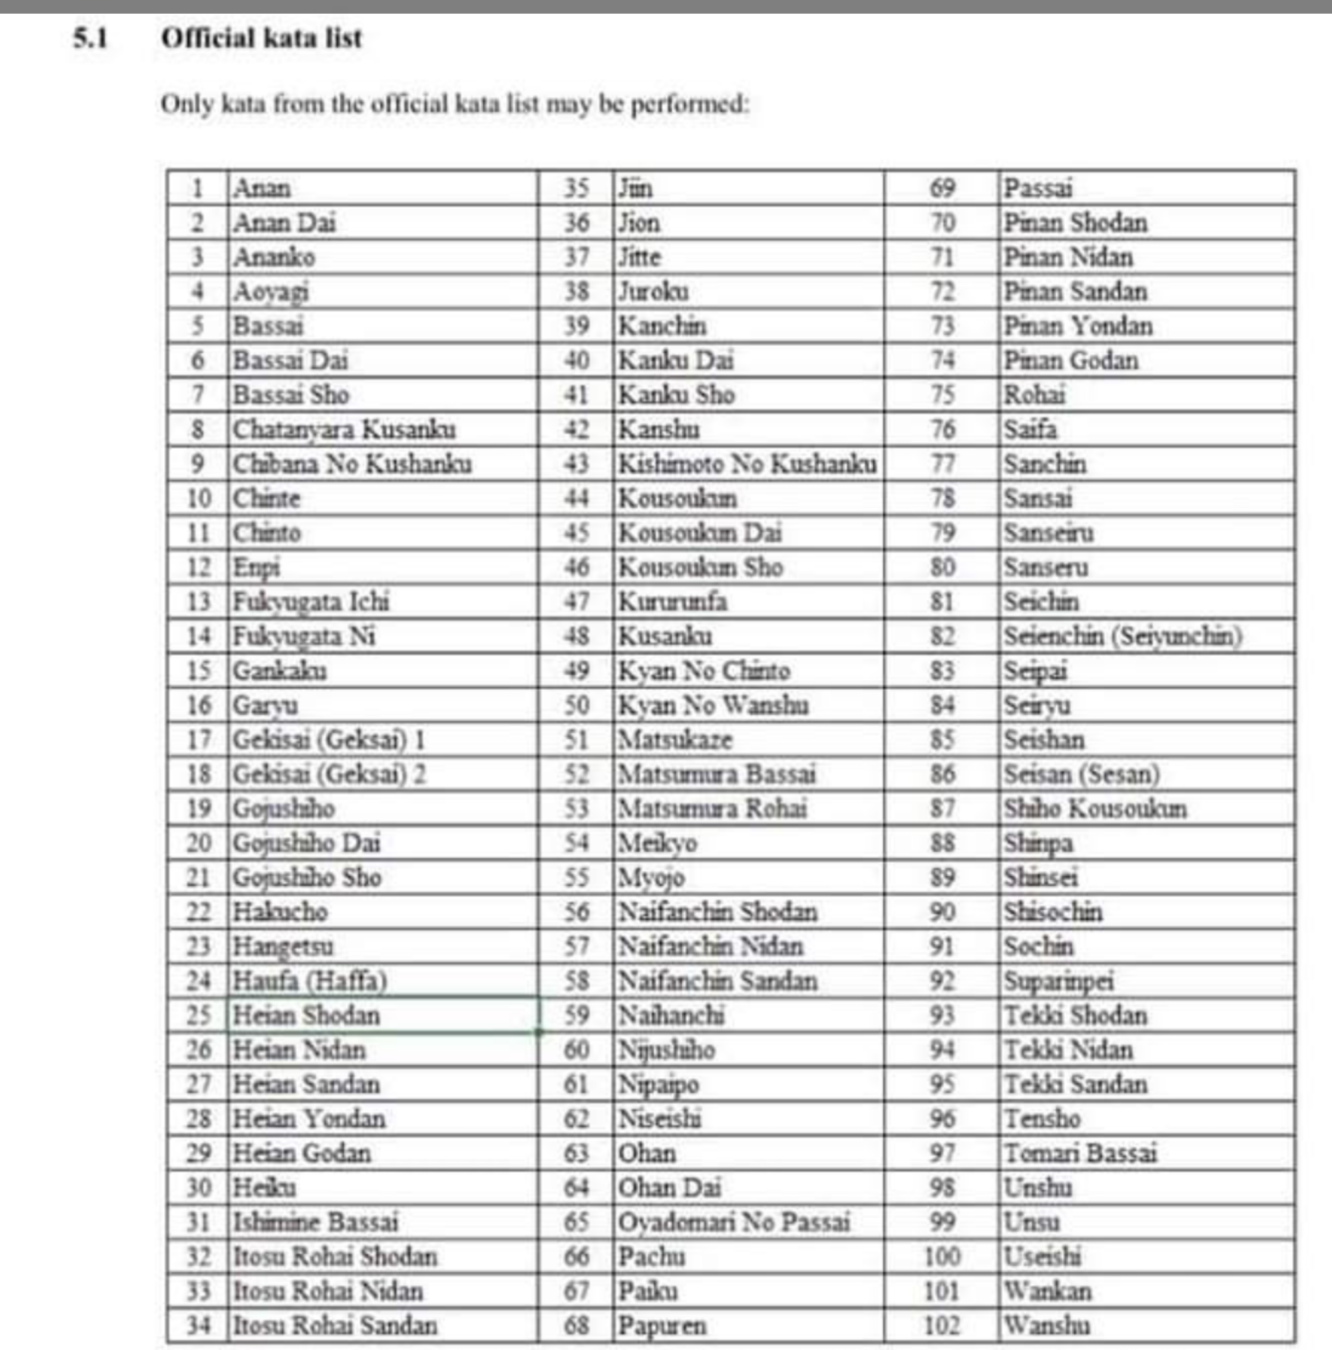

Please note
Any under-subscribed categories may be merged with another or cancelled, and any oversubscribed categories may be split without prior notice at the discretion of the event organiser.
The organisers reserve the right to amend/alter any rules without prior notice.
For Future Dates of Competitions/Seminars organised by Paul Campbell :
www.pckarate.co.uk

Dates for your diaries: Wayne Otto 2023 Boot Camp Seminars : Saturday 7th & Sunday 8th October 2023 @ Dudley.

