MONTREAL OPEN INTERNATIONAL 2024
Saturday and Sunday, May 4 and 5, 2024

Centre Pierre-Charbonneau
3000, rue Viau, Montréal, QC, CANADA, H1V 3J3
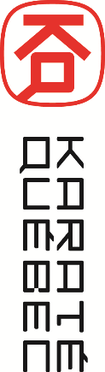

Montreal, April 2, 2024

Re: Invitation Montreal Open International 2024

Greetings,

It is my great pleasure to invite you to join us at the 19th edition of the MONTREAL OPEN INTERNATIONAL taking place on Saturday and Sunday, May 4 and 5, 2024.

The MONTREAL OPEN INTERNATIONAL 2024 will offer the possibility for participants to compete in two divisions: ELITE or NON-ELITE, to allow athletes to measure themselves against participants with similar skill level.

The ELITE division will offer prize money for a total of $5,000 CAD provided there is a sufficient number of participants in the categories. This amount will be shared amongst the winners and finalists of the Senior Elite Kata and the Elite Kumite Open categories. The winners in each category will be awarded a $1,000 prize and the finalists, a $250 prize. The NON-ELITE division will offer numerous opportunities for the participants to meet athletes from various countries.

Referees holding a valid provincial, national, continental or world license are welcome to officiate at the MONTREAL OPEN INTERNATIONAL 2024. The competition will utilize the valid WKF (World Karate Federation) rules of competition for both divisions.

Entry door for North America, the city of Montreal offers the charm of the French-speaking culture and the attraction of an international multicultural metropolis, all in harmony.

More information is available on the KARATE QUEBEC website under the tab Open International de Montreal 2024 or on Sportdata.

We hope to see you at the MONTREAL OPEN INTERNATIONAL 2024.

Best regards,

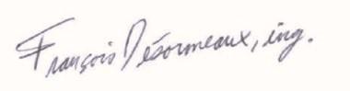
François Désormeaux, ing.
President
KARATÉ QUÉBEC

KARATE QUEBEC is the governing organization recognized by the Ministry of Education and Higher Education of the Government of Quebec as well as by Karate Canada, whose primary mission is to provide leadership in matters of development and promoting karate in Quebec.

KARATÉ QUÉBEC
Le karaté à son plus haut niveau !

